|  |  |
| --- | --- |
|  | **GST 113**  **NIGERIA PEOPLES & CULTURE** |
|  | Sarah AJIYA  Cordelia CLAYTON  Tobi JOHNSON  Dinatu B. TANKO  Felix ODOFIN  Cynthia M. SAIDU |

|  |
| --- |
| **[© 2019]** |
|  |



**LESSON 9**

**THE DYNAMICS OF THE EVOLUTION OF NIGERIA AS APOLITICAL UNIT I**

**The British and the Creation of Nigeria**

The British who have often been credited with the creation of Nigeria were not the first Europeans to land in Nigeria. The Portuguese were the first Europeans to arrive Nigeria through Bini Kingdom. According to Hodgkin: “the second half of the 15th century saw the arrival of the first Europeans in Benin, the Portuguese *Ruy de Sequeira* in 1472 in Ewuare’s reign and Alfonzo de Aviero in 1484 in Ozolua’s reign”.

The name “Nigeria” was first used by Flora Shaw, who was to become the wife of Frederick Lugard, in an article to the London Times of 1899 to refer to the territories around the River Niger in Northern Nigeria. The name was originally applied to the Protectorate of Northern Nigeria before it later came to be applied to the whole country.

**The Trans-Atlantic Slave Trade**

The Trans-Atlantic slave trade was the unfortunate channel that first put the British in contact with Nigeria. The trade got to maturity in the 16th century. For close to three centuries, coastal Nigeria’s relations with the British were dominated by the trans-Atlantic slave trade. But in the early decade of the 19th century, the British decided to abolish the trans- Atlantic slave trade. They did so through the operations of the British West African Naval Squadron. You should know that it is tautological to say that the trade was very damaging to Africa in general and Nigeria in particular.

**The Period of Legitimate Commerce**

After three centuries of shameful slave trade, came the so-called period of legitimate commerce. Of course, this was another golden opportunity for the Europeans to get more directly involved in the affairs of the African States. Europeans first introduced the “Gun-boat” politics. To them, this was important because some “erring” African states were threatened with attack and in some cases, were actually attacked. It was under the umbrella of such happenings that the British first formally annexed Nigerian territory. In 1861, they took Lagos as a colony. But, the bulk of Nigerian territory was occupied in the late 19th century. This happened through dubious treaties that were signed with some Nigerian potentates, and through military conquest of states and deportation of their rulers. Despite the resistance of some brave and courageous Nigerians such as Jaja of Opobo, Nana of Itsekiri, Ovonramwen of Benin and Attahiru of Sokoto, they could not stop the British usurpation of their independence and authority.

**The Amalgamation Processes**

Before the year 1900, all the different parts of Nigeria conquered by the British were still under their original administration. But by 1900, the whole Nigeria was under the responsibility of the British Colonial Office.

**May 1906 Amalgamation**

The May 1906 amalgamation is known as the first ever amalgamation of the British in Nigeria. British government amalgamated Lagos colony and protectorate with the protectorate of Southern Nigeria to form the new colony and protectorate of Southern Nigeria. You should know that since the whole Nigeria was under the responsibility of the British government they did not bother to seek the views of Nigerians in the two territories as to whether or not they supported the amalgamation. Besides, Tamuno (1980) observes that the primary aim of the 1906 amalgamation was purely economic, that is, “to use the better financial position of the protectorate of Southern Nigerian to cover the costs of administration and development in the financially weak colony and protectorate of Lagos, then saddled with the white elephant of a railway in need of extension since 1901”.

**January 1914 Amalgamation**

The second amalgamation was that of 1914. In January 1914, the British government amalgamated Northern and Southern Nigeria. The principal reason for this is the same as that of May 1906. The Northern protectorate was not as economically buoyant as the colony and protectorate of Southern Nigeria. That was why, for the British imperial offices, since the Southern trade was booming, amalgamation would allow the surpluses acquired in the south to be used in the North, and this was expected to reduce British Treasury responsibility. Sir Frederick Lugard (later became Lord) is best known as the father of the “January 1914” amalgamation.

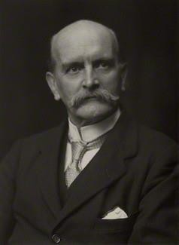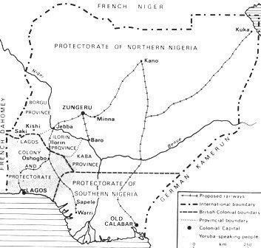

Lord Frederick Lugard

**Some Consequences of the Amalgamation**

It can be argued that even if the initial intention of the amalgamation process was to make of Nigeria a political unit, it did practically fail. According to Hatch (1970) the amalgamation of Nigeria was carried out with many unanswered questions such as:

What would be the effect of uniting the Fulani emirates – with their comparatively static, traditionalist outlook – with the thrusting, competitive, individualistic society of the south, acquiring knowledge from a growing number of mission schools, which were making available an expanding clerical class? How would societies that only a few years earlier had been rival and often hostile states live together under one administration? Should they form a single nation? If so, how could a single allegiance be created? In any case, what was the central objective of British policy? Was it to build an empire permanently subordinate to Britain, to act as a trustee for some shadowy African future, or to encourage a natural spirit leading to ultimate self- government?”

Today, it is obvious that the tragedy of Nigeria’s history and its people is not so much to be found in the diversity of these groups that were brought together under amalgamation. Rather, the real tragedy is that British colonial policy in Nigeria after amalgamation tended to be divisive and isolationist in terms of keeping the peoples of the two main protectorates separate. For instance, while the 1914 amalgamation gave the northern and southern provinces a common political head in the person of Lugard, no uniform style of administration developed in either group of provinces. Despite the amalgamation of 1914, Nigeria still operated as a federation of two groups of provinces between 1914 and 1939. Later on April 1, 1939, the British government split the former Southern provinces into Eastern and Western provinces. This tripartite division of Nigeria remained well into the independence period, until 1963 when the Mid-Western region was created, and the Northern Region was split for the first time in 1967.

What role did the amalgamations play in the evolution of Nigeria as a political unit?